Колосов Василий, 64-я когорта — 4-й спринт

## Задание 1

Команда или последовательность команд, которой удалось получить нужные логи:

grep -R ^233.201 ~/logs/2019/12

Логи:

/home/morty/logs/2019/12/apache_2019-12-18.txt:233.201.188.154 - - [18/12/2019:21:46:01 +0000] "DELETE /events HTTP/1.1" 403 3971

/home/morty/logs/2019/12/apache_2019-12-21.txt:233.201.182.9 - - [21/12/2019:21:56:20 +0000] "PATCH /users HTTP/1.1" 400 4118

## Задание 2

Команды, которые создают директории bug1 и events:

cd ~

mkdir bug1 команда, которая создает директорию bug1

cd bug1

touch main.txt

mkdir events команда, которая создает директорию events

cd events

touch 400.txt 500.txt

Команда, которой выбираешь запросы за указанный период. Это те запросы, которыми ты отбираешь логи в файл main.txt:

grep -R 30.12.2019:21:3. ~/logs

grep -R 31.12.2019:21:3. ~/logs

cat logs/2019/12/apache_2019-12-30.txt |grep -R 30.12.2019:21:3. ~/logs >bug1/main.txt

cat logs/2019/12/apache_2019-12-31.txt |grep -R 31.12.2019:21:3. ~/logs >>bug1/main.txt

Команды, которыми ты кладёшь логи в файлы 400.txt и 500.txt из main.txt:

cat bug1/main.txt |grep -R 400 ~/bug1 >bug1/events/400.txt

grep -i -w "500" bug1/main.txt > bug1/events/500.txt

400.txt

/home/morty/bug1/main.txt:/home/morty/logs/2019/12/apache_2019-12-30.txt:101.255.159.211 - - [30/12/2019:21:37:59 +0000] "GET /auth HTTP/1.1" 400 2324

/home/morty/bug1/main.txt:/home/morty/logs/2019/12/apache_2019-12-30.txt:80.76.98.203 - - [30/12/2019:21:38:00 +0000] "POST /playbooks HTTP/1.1" 400 3045

/home/morty/bug1/main.txt:/home/morty/logs/2019/12/apache_2019-12-30.txt:85.64.63.255 - - [30/12/2019:21:38:13 +0000] "PATCH /collectors HTTP/1.1" 400 2291

/home/morty/bug1/main.txt:/home/morty/logs/2019/12/apache_2019-12-30.txt:184.79.247.161 - - [30/12/2019:21:38:13 +0000] "PUT /alerts HTTP/1.1" 400 3557

/home/morty/bug1/main.txt:/home/morty/logs/2019/12/apache_2019-12-30.txt:93.2.134.22 - - [30/12/2019:21:39:39 +0000] "DELETE /alerts HTTP/1.1" 400 3701

/home/morty/bug1/main.txt:/home/morty/logs/2019/12/apache_2019-12-31.txt:86.34.86.182 - - [31/12/2019:21:35:10 +0000] "POST /auth HTTP/1.1" 400 3626

/home/morty/bug1/main.txt:/home/morty/logs/2019/12/apache_2019-12-31.txt:167.37.16.117 - - [31/12/2019:21:35:17 +0000] "PATCH /customers HTTP/1.1" 400 3294

/home/morty/bug1/main.txt:/home/morty/logs/2019/12/apache_2019-12-31.txt:199.128.92.19 - - [31/12/2019:21:35:43 +0000] "PUT /users HTTP/1.1" 400 4180

/home/morty/bug1/main.txt:/home/morty/logs/2019/12/apache_2019-12-31.txt:162.152.99.143 - - [31/12/2019:21:35:59 +0000] "PUT /users HTTP/1.1" 400 4606

/home/morty/bug1/main.txt:/home/morty/logs/2019/12/apache_2019-12-31.txt:83.115.59.224 - - [31/12/2019:21:37:26 +0000] "GET /alerts HTTP/1.1" 400 3489

/home/morty/bug1/main.txt:/home/morty/logs/2019/12/apache_2019-12-31.txt:194.10.97.226 - - [31/12/2019:21:37:31 +0000] "DELETE /lists HTTP/1.1" 400 2447

/home/morty/bug1/main.txt:/home/morty/logs/2019/12/apache_2019-12-31.txt:180.99.214.40 - - [31/12/2019:21:37:44 +0000] "DELETE /alerts HTTP/1.1" 400 2077

/home/morty/bug1/main.txt:/home/morty/logs/2019/12/apache_2019-12-31.txt:154.152.205.4 - - [31/12/2019:21:37:50 +0000] "GET /playbooks HTTP/1.1" 400 3324

/home/morty/bug1/main.txt:/home/morty/logs/2019/12/apache_2019-12-31.txt:197.82.125.54 - - [31/12/2019:21:37:52 +0000] "PUT /fieldsets HTTP/1.1" 400 4365

/home/morty/bug1/main.txt:/home/morty/logs/2019/12/apache_2019-12-31.txt:115.89.87.219 - - [31/12/2019:21:38:06 +0000] "PUT /playbooks HTTP/1.1" 400 2589

/home/morty/bug1/main.txt:/home/morty/logs/2019/12/apache_2019-12-31.txt:100.77.15.14 - - [31/12/2019:21:38:07 +0000] "GET /fieldsets HTTP/1.1" 400 4911

/home/morty/bug1/main.txt:/home/morty/logs/2019/12/apache_2019-12-31.txt:22.33.159.242 - - [31/12/2019:21:38:07 +0000] "GET /playbooks HTTP/1.1" 400 3955

/home/morty/bug1/main.txt:/home/morty/logs/2019/12/apache_2019-12-31.txt:149.148.229.11 - - [31/12/2019:21:39:16 +0000] "GET /users HTTP/1.1" 400 2071

/home/morty/bug1/main.txt:/home/morty/logs/2019/12/apache_2019-12-31.txt:236.107.64.192 - - [31/12/2019:21:39:17 +0000] "PATCH /users HTTP/1.1" 400 2791

/home/morty/bug1/main.txt:/home/morty/logs/2019/12/apache_2019-12-31.txt:24.156.105.39 - - [31/12/2019:21:39:23 +0000] "GET /lists HTTP/1.1" 400 2902

/home/morty/bug1/main.txt:/home/morty/logs/2019/12/apache_2019-12-31.txt:193.50.164.254 - - [31/12/2019:21:39:23 +0000] "PUT /playbooks HTTP/1.1" 400 3296

/home/morty/bug1/main.txt:/home/morty/logs/2019/12/apache_2019-12-31.txt:18.123.104.91 - - [31/12/2019:21:39:52 +0000] "GET /collectors HTTP/1.1" 400 4372

/home/morty/bug1/main.txt:/home/morty/logs/2019/12/apache_2019-12-31.txt:234.218.148.4 - - [31/12/2019:21:39:54 +0000] "PUT /users HTTP/1.1" 400 2509

500.txt.

/home/morty/bug1/main.txt:/home/morty/logs/2019/12/apache_2019-12-30.txt:64.250.112.189 - - [30/12/2019:21:35:13 +0000] "PUT /parsers HTTP/1.1" 500 4639

/home/morty/bug1/main.txt:/home/morty/logs/2019/12/apache_2019-12-30.txt:193.253.101.180 - - [30/12/2019:21:35:31 +0000] "PATCH /alerts HTTP/1.1" 500 2944

/home/morty/bug1/main.txt:/home/morty/logs/2019/12/apache_2019-12-30.txt:197.106.117.194 - - [30/12/2019:21:35:31 +0000] "PATCH /parsers HTTP/1.1" 500 3519

/home/morty/bug1/main.txt:/home/morty/logs/2019/12/apache_2019-12-30.txt:247.124.71.67 - - [30/12/2019:21:35:45 +0000] "PUT /alerts HTTP/1.1" 500 2746

/home/morty/bug1/main.txt:/home/morty/logs/2019/12/apache_2019-12-30.txt:62.88.204.119 - - [30/12/2019:21:35:51 +0000] "PUT /auth HTTP/1.1" 500 2666

/home/morty/bug1/main.txt:/home/morty/logs/2019/12/apache_2019-12-30.txt:125.156.142.26 - - [30/12/2019:21:36:01 +0000] "PATCH /events HTTP/1.1" 500 3460

/home/morty/bug1/main.txt:/home/morty/logs/2019/12/apache_2019-12-30.txt:144.170.212.70 - - [30/12/2019:21:36:04 +0000] "DELETE /parsers HTTP/1.1" 500 2599

/home/morty/bug1/main.txt:/home/morty/logs/2019/12/apache_2019-12-30.txt:59.39.200.252 - - [30/12/2019:21:36:05 +0000] "GET /alerts HTTP/1.1" 500 2650

/home/morty/bug1/main.txt:/home/morty/logs/2019/12/apache_2019-12-30.txt:150.136.200.100 - - [30/12/2019:21:37:24 +0000] "POST /lists HTTP/1.1" 500 2684

/home/morty/bug1/main.txt:/home/morty/logs/2019/12/apache_2019-12-30.txt:84.81.25.45 - - [30/12/2019:21:37:25 +0000] "POST /auth HTTP/1.1" 500 2052

/home/morty/bug1/main.txt:/home/morty/logs/2019/12/apache_2019-12-30.txt:30.222.160.141 - - [30/12/2019:21:37:30 +0000] "PATCH /parsers HTTP/1.1" 500 2017

/home/morty/bug1/main.txt:/home/morty/logs/2019/12/apache_2019-12-30.txt:117.87.158.36 - - [30/12/2019:21:37:34 +0000] "POST /fieldsets HTTP/1.1" 500 4056

/home/morty/bug1/main.txt:/home/morty/logs/2019/12/apache_2019-12-30.txt:212.153.128.212 - - [30/12/2019:21:37:42 +0000] "PUT /fieldsets HTTP/1.1" 500 3259

/home/morty/bug1/main.txt:/home/morty/logs/2019/12/apache_2019-12-30.txt:58.188.83.217 - - [30/12/2019:21:37:46 +0000] "POST /playbooks HTTP/1.1" 500 3947

/home/morty/bug1/main.txt:/home/morty/logs/2019/12/apache_2019-12-30.txt:193.123.131.146 - - [30/12/2019:21:37:47 +0000] "PUT /lists HTTP/1.1" 500 3902

/home/morty/bug1/main.txt:/home/morty/logs/2019/12/apache_2019-12-30.txt:182.7.179.91 - - [30/12/2019:21:37:48 +0000] "GET /users HTTP/1.1" 500 2950

/home/morty/bug1/main.txt:/home/morty/logs/2019/12/apache_2019-12-30.txt:10.25.168.164 - - [30/12/2019:21:38:05 +0000] "PATCH /playbooks HTTP/1.1" 500 3858

/home/morty/bug1/main.txt:/home/morty/logs/2019/12/apache_2019-12-30.txt:215.201.210.173 - - [30/12/2019:21:38:11 +0000] "PATCH /customers HTTP/1.1" 500 3277

/home/morty/bug1/main.txt:/home/morty/logs/2019/12/apache_2019-12-30.txt:179.241.103.167 - - [30/12/2019:21:39:23 +0000] "POST /lists HTTP/1.1" 500 3669

/home/morty/bug1/main.txt:/home/morty/logs/2019/12/apache_2019-12-30.txt:147.188.170.252 - - [30/12/2019:21:39:33 +0000] "POST /fieldsets HTTP/1.1" 500 3313

/home/morty/bug1/main.txt:/home/morty/logs/2019/12/apache_2019-12-30.txt:1.249.123.189 - - [30/12/2019:21:39:36 +0000] "PATCH /alerts HTTP/1.1" 500 4734

/home/morty/bug1/main.txt:/home/morty/logs/2019/12/apache_2019-12-30.txt:124.114.135.105 - - [30/12/2019:21:39:41 +0000] "PATCH /customers HTTP/1.1" 500 3348

/home/morty/bug1/main.txt:/home/morty/logs/2019/12/apache_2019-12-30.txt:35.215.100.202 - - [30/12/2019:21:39:43 +0000] "PUT /alerts HTTP/1.1" 500 4345

/home/morty/bug1/main.txt:/home/morty/logs/2019/12/apache_2019-12-30.txt:86.222.23.128 - - [30/12/2019:21:39:44 +0000] "PATCH /alerts HTTP/1.1" 500 2230

/home/morty/bug1/main.txt:/home/morty/logs/2019/12/apache_2019-12-30.txt:20.161.75.95 - - [30/12/2019:21:39:48 +0000] "DELETE /users HTTP/1.1" 500 2412

/home/morty/bug1/main.txt:/home/morty/logs/2019/12/apache_2019-12-30.txt:196.18.151.117 - - [30/12/2019:21:39:55 +0000] "PUT /events HTTP/1.1" 500 4439

/home/morty/bug1/main.txt:/home/morty/logs/2019/12/apache_2019-12-30.txt:77.101.138.151 - - [30/12/2019:21:39:57 +0000] "PUT /lists HTTP/1.1" 500 2194

/home/morty/bug1/main.txt:/home/morty/logs/2019/12/apache_2019-12-31.txt:208.205.133.127 - - [31/12/2019:21:35:17 +0000] "DELETE /alerts HTTP/1.1" 500 4561

/home/morty/bug1/main.txt:/home/morty/logs/2019/12/apache_2019-12-31.txt:20.145.255.91 - - [31/12/2019:21:35:30 +0000] "GET /parsers HTTP/1.1" 500 3051

/home/morty/bug1/main.txt:/home/morty/logs/2019/12/apache_2019-12-31.txt:91.66.134.13 - - [31/12/2019:21:35:53 +0000] "POST /lists HTTP/1.1" 500 3319

/home/morty/bug1/main.txt:/home/morty/logs/2019/12/apache_2019-12-31.txt:31.88.211.206 - - [31/12/2019:21:35:57 +0000] "DELETE /events HTTP/1.1" 500 2325

/home/morty/bug1/main.txt:/home/morty/logs/2019/12/apache_2019-12-31.txt:171.37.114.114 - - [31/12/2019:21:37:39 +0000] "DELETE /fieldsets HTTP/1.1" 500 3253

/home/morty/bug1/main.txt:/home/morty/logs/2019/12/apache_2019-12-31.txt:223.157.242.167 - - [31/12/2019:21:37:59 +0000] "POST /users HTTP/1.1" 500 2283

## 

# **База данных**

## Задание 1

Число автомобилей:

5529

Запрос, которым тебе удалось решить задачу.

SELECT COUNT(vehicle_id) FROM cabs;

## Задание 2

Список компаний с числом автомобилей меньше 100.

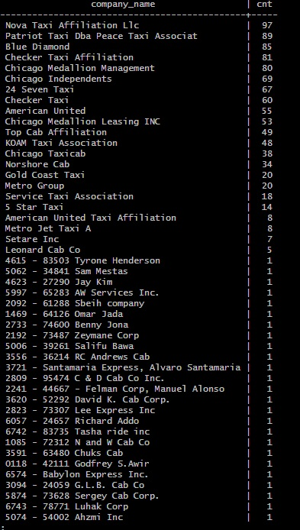

Запрос, которым тебе удалось решить задачу.

SELECT company_name, COUNT(*) cnt FROM cabs GROUP BY company_name HAVING COUNT(*)<=100 ORDER BY cnt DESC;

## Задание 3

Таблица с данными за указанный период.

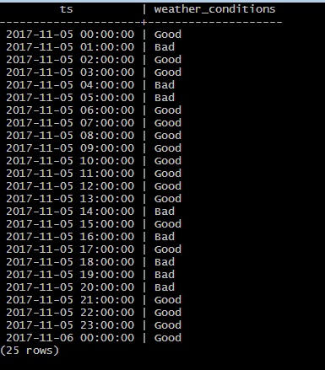

Запрос, которым удалось решить задачу.

SELECT ts, CASE WHEN description LIKE '%rain%' OR description LIKE '%storm%' THEN 'Bad' ELSE 'Good' END AS weather_conditions FROM weather_records WHERE ts >= '2017-11-05 00:00' AND ts <= '2017-11-06 00:00';

## Задание 4

Таблица с данными за указанный период.

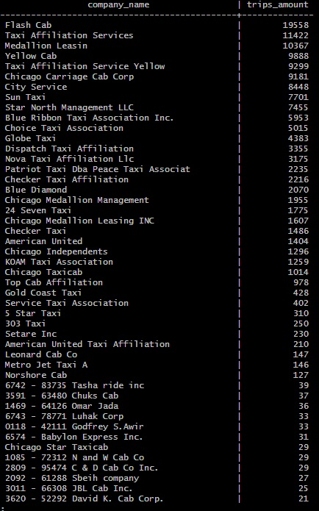

Запрос, которым удалось решить задачу.

SELECT cabs.company_name as company_name, COUNT(trips.trip_id) AS trips_amount FROM trips INNER JOIN cabs on trips.cab_id = cabs.cab_id WHERE start_ts >= '2017-11-15 00:00' AND start_ts <= '2017-11-16 23:59' GROUP BY company_name ORDER BY trips_amount DESC;